Breast Cancer Data Set

Naïve Bayes

Data Discription

Data columns (total 31 columns):

diagnosis 569 non-null object

radius_mean 569 non-null float64

texture_mean 569 non-null float64

perimeter_mean 569 non-null float64

area_mean 569 non-null float64

smoothness_mean 569 non-null float64

compactness_mean 569 non-null float64

concavity_mean 569 non-null float64

concave points_mean 569 non-null float64

symmetry_mean 569 non-null float64

fractal_dimension_mean 569 non-null float64

radius_se 569 non-null float64

texture_se 569 non-null float64

perimeter_se 569 non-null float64

area_se 569 non-null float64

smoothness_se 569 non-null float64

compactness_se 569 non-null float64

concavity_se 569 non-null float64

concave points_se 569 non-null float64

symmetry_se 569 non-null float64

fractal_dimension_se 569 non-null float64

radius_worst 569 non-null float64

texture_worst 569 non-null float64

perimeter_worst 569 non-null float64

area_worst 569 non-null float64

smoothness_worst 569 non-null float64

compactness_worst 569 non-null float64

concavity_worst 569 non-null float64

concave points_worst 569 non-null float64

symmetry_worst 569 non-null float64

fractal_dimension_worst 569 non-null float64

dtypes: float64(30), object(1)

Heat Map

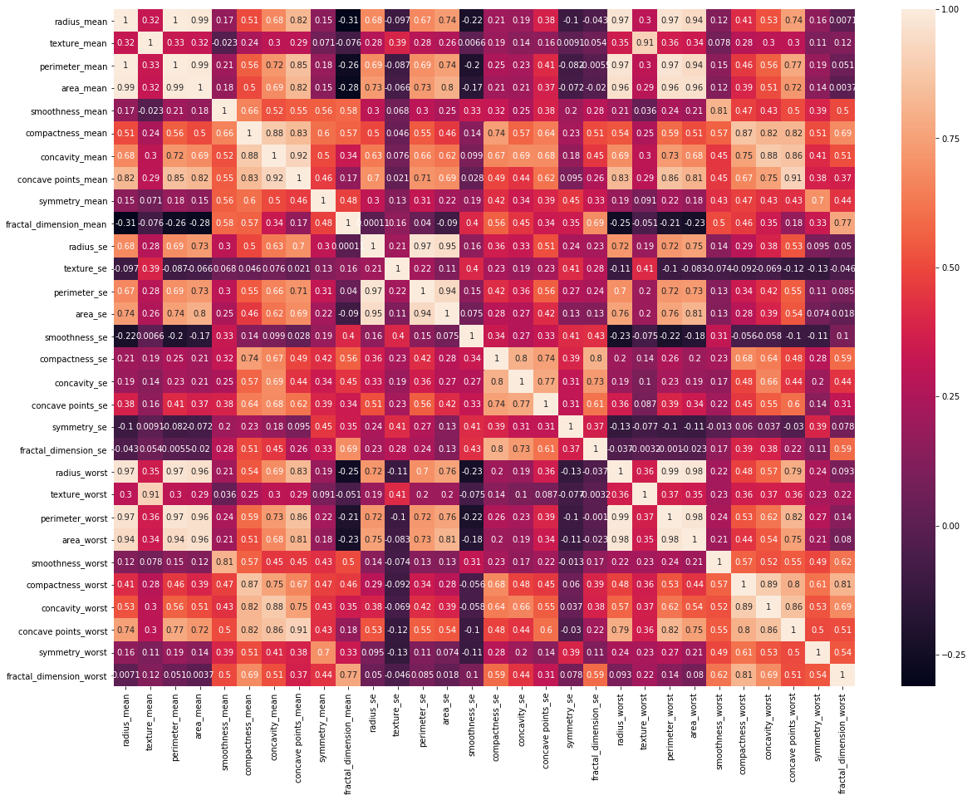

Box Plot

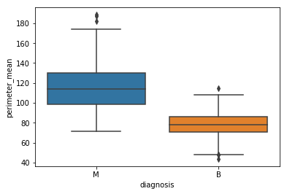

Accuracy 92.39766081871345

Classification report

precision recall f1-score support

B 0.93 0.95 0.94 105

M 0.92 0.88 0.90 66

avg / total 0.92 0.92 0.92 171

SVM

Accuracy=94.15204678362574

classification report

|  |
| --- |
|  |
| precision recall f1-score support |
|  |
| B 0.94 0.97 0.95 105 |
| M 0.95 0.89 0.92 66 |
|  |
| avg / total 0.94 0.94 0.94 171 |

classification_report